Jewellery House

By

_________

Level-6

Final Project

Table of Contents

Project Proposal 3

Goals and Objectives 3

Project Scope 3

Project Specifications 3

Target Audience 3

Project Deliverables 4

Resource Requirements 4

Project Tasks and Milestones 4

Project Assumptions 5

Project Report 5

Detail Design 6

Login Page 6

Home Page 6

Register Page 7

Admin Jewellery Type Page 7

Admin Gender Type Page 8

All Jewellery Guest Page 8

Jewelleries Details Guest Page 9

Add Review User Page 9

Project Testing 10

User Manual 10

Summary 10

System Configuration 10

User Access Levels 10

# 

# Project Proposal

## Goals and Objectives

The main goal or aim of the project is to implement an online web application named “Jewellery House”. The main purpose of this web application to build a secure and easily accessible way to provide information of jewellery and allow register user to share their review regarding jewellery. Admin has CMS panel to manage all information available on web site and registered user capable to share their review of jewellery.

## Project Scope

The scope of this project is to implement an app named “Jewellery House” with the help of which provide Jewellery Information at user hand available any place. The duration of the project is 20 working days which is equals to 4 weeks.

## Project Specifications

* Admin login/logout
* Add, edit, delete and check details of Gender, Jewellery Type and Jewellery information.
* Admin can delete, edit and check all information available in database.
* Admin capable to create new admin.
* Register User and Admin can login/logout.
* Registered User can share his/her review online.

## Target Audience

The target audience for this project is the people of organization and this web application specific to an organization. The age can go from 18 plus to 100 plus.

## Project Deliverables

The deliverables of the project are:

|  |  |
| --- | --- |
| Deliverable | Description |
| Final Report | This will be the final report of the project. |
| Coding | The executable code of the project will go under this. |
| Documentation | This portrays the documentation of the project. |
| Testing | All the test details will be covered in this part. |

## Resource Requirements

* Windows Operating System.
* Microsoft word for documentation.
* Asp.net MVC Framework
* 64-bit Processor and 4 GB or more RAM
* Identity framework- ASP

## Project Tasks and Milestones

|  |  |  |  |  |
| --- | --- | --- | --- | --- |
| **Tasks** | **Week-1** | **Week-2** | **Week-3** | **Week-4** |
| Brainstorming and analysis |  |  |  |  |
| Planning and initial meeting Project Proposal document. |  |  |  |  |
| Database Design and UI Design |  |  |  |  |
| Identity framework implementation |  |  |  |  |
| Coding for admin and reporter |  |  |  |  |
| Testing |  |  |  |  |
| Final Documentation and closing |  |  |  |  |

## Project Assumptions

Following are the assumption made while implementing the project:

* One Admin and one user will be registered by default.
* Application will be free and open source.

# Project Report

#### Functional and Non-Functional

|  |  |
| --- | --- |
| Users | Functional |
| Admin | * Login/logout * Capable to create new admin * Admin can add, edit, delete, check details for gender, jewellery type and information of jewellery. * Admin capable to delete the Registered user review which are unappropriated |
| Registered User | * Capable to share his/her review about jewellery * Login/logout |
|  | Non- Functional |
|  | * High speed * Fast Loading time * High performance and security * All browsers compatibility. |

## Detail Design

### Login Page

Here, user can login with his/her credential to access appropriate content according to their role.

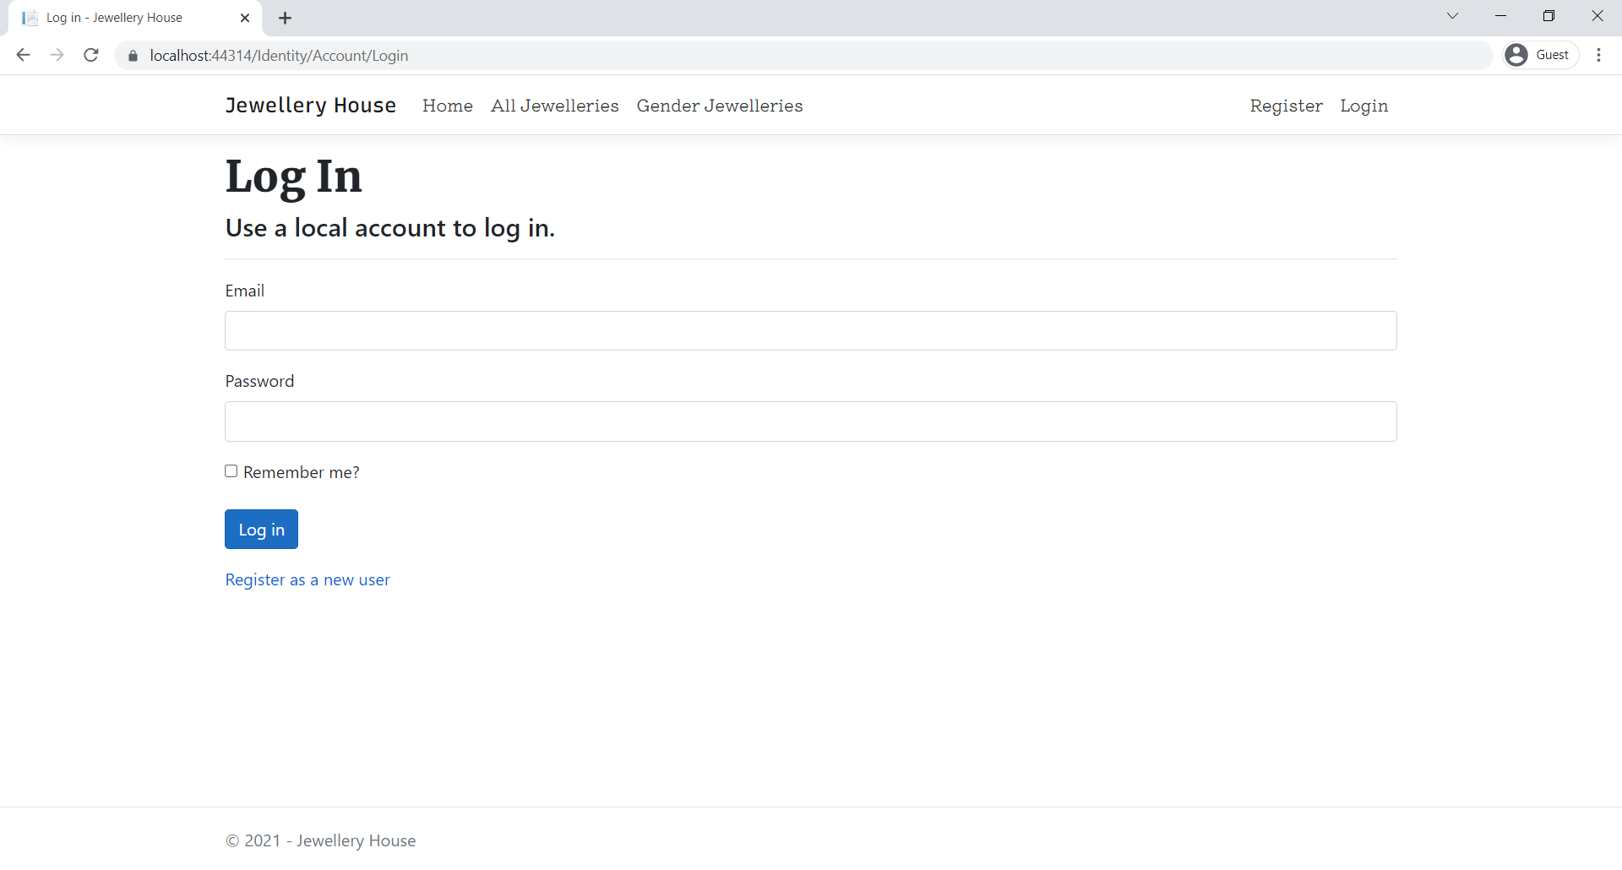

### Home Page

It is a landing page of Jewellery House web application which display a slider and information of Jewellery Section

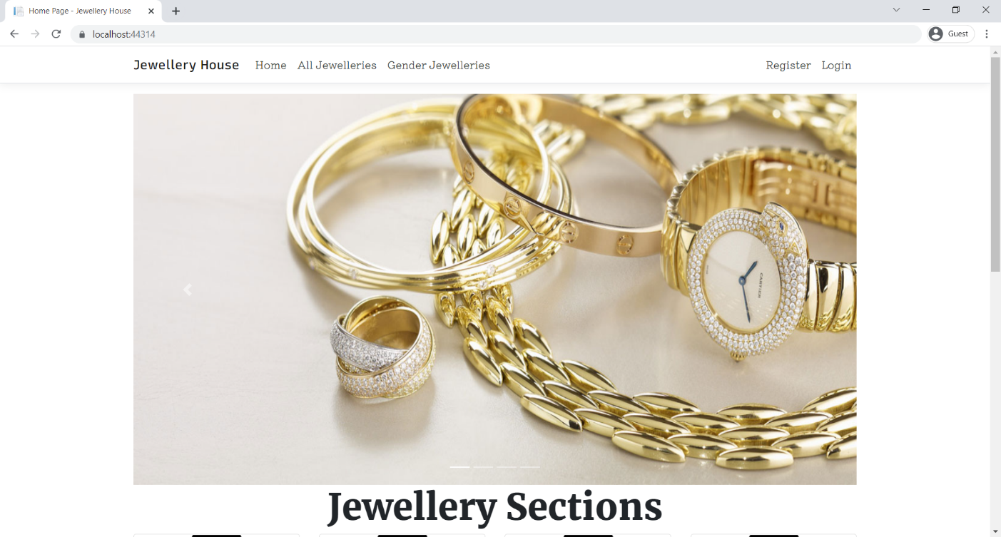

### Register Page

Here, a visitor can register to Jewellery House web application

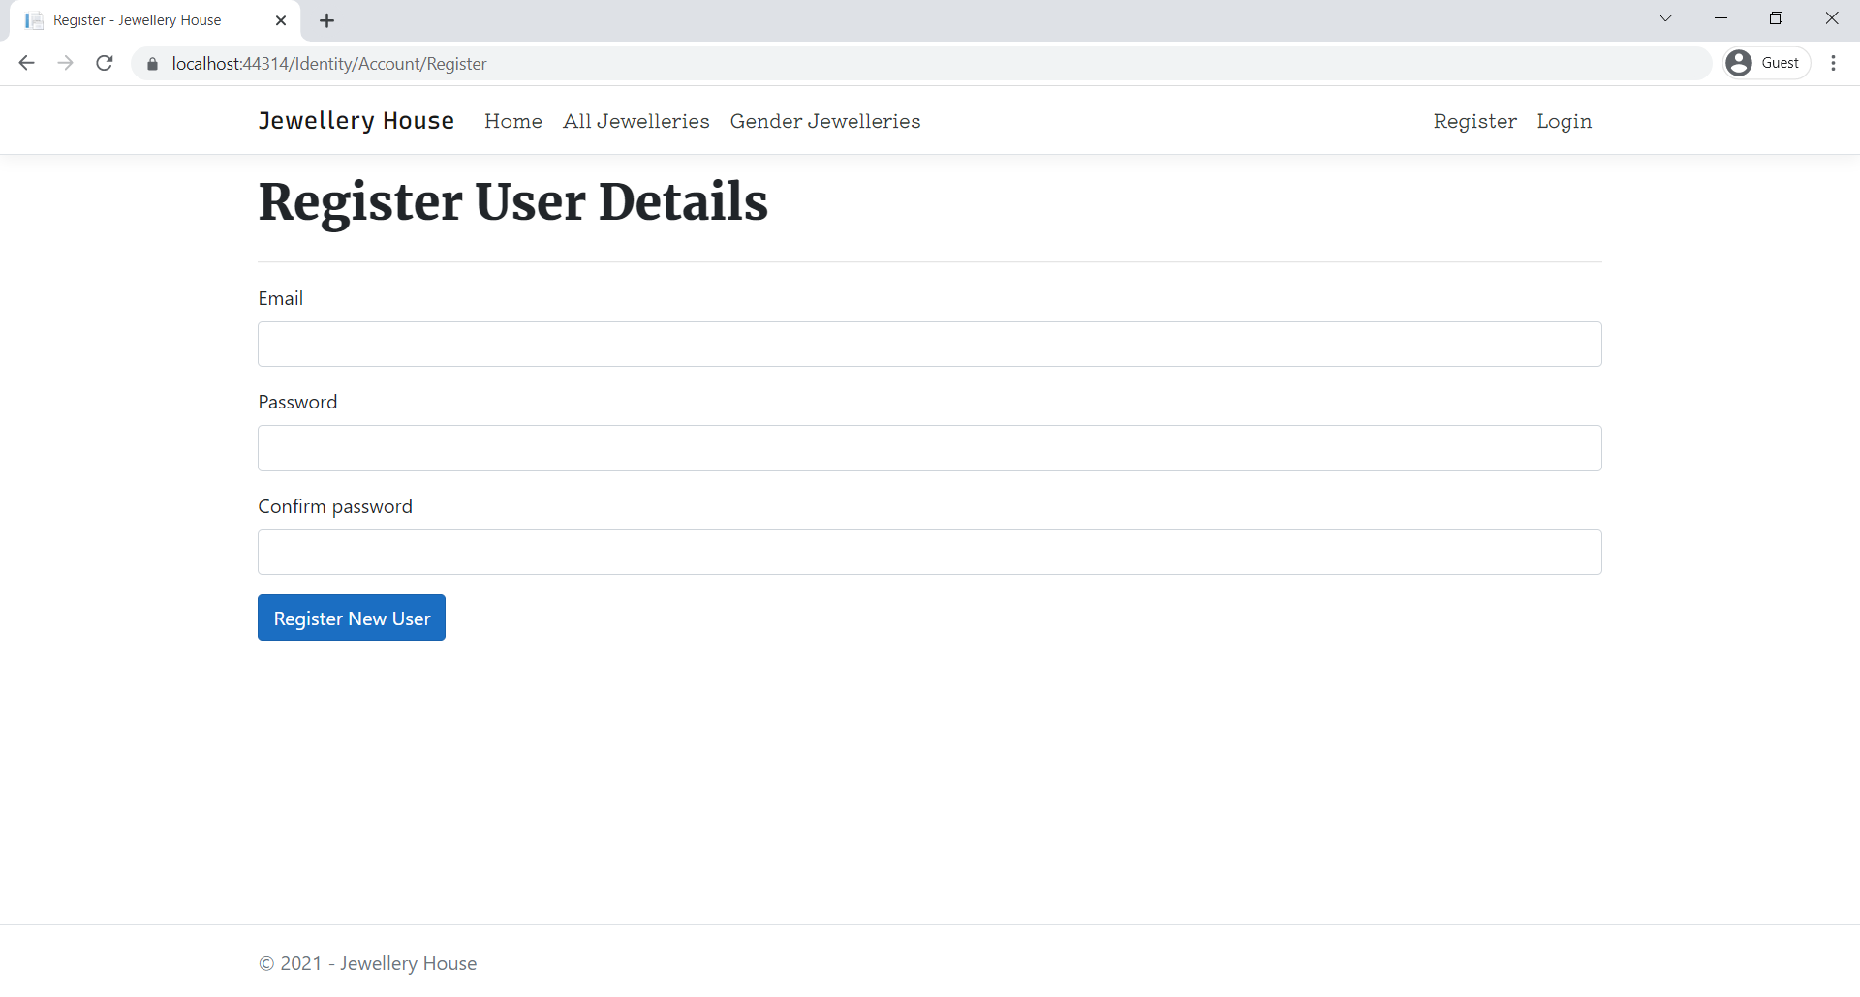

### Admin Jewellery Type Page

This page is for admin user to control the Jewellery Type or section.

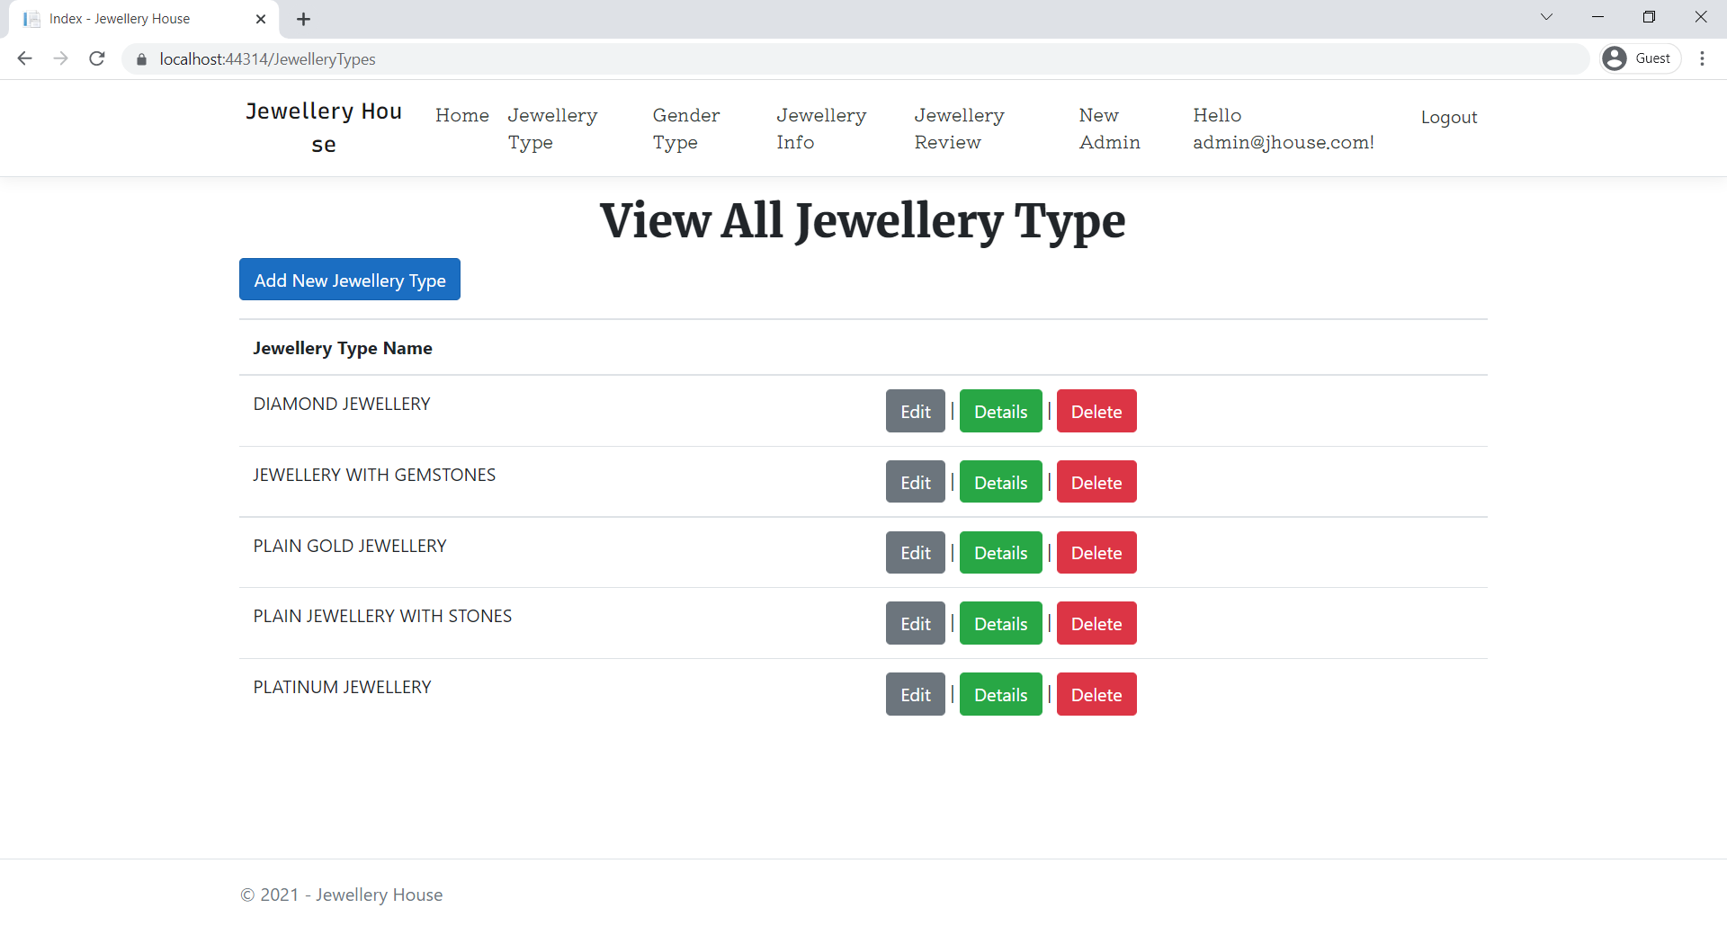

### 

### Admin Gender Type Page

With the help of this page, admin can manage gender category for jewellery.

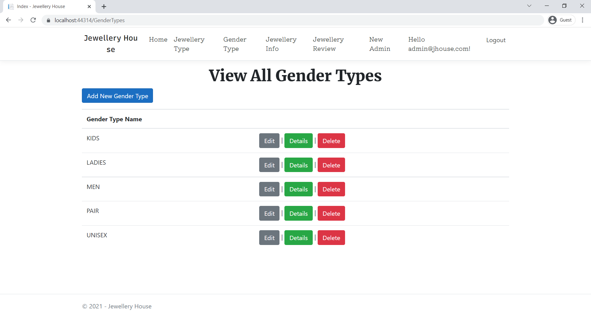

### All Jewellery Guest Page

This page display all jewellery information for all visitor or registered user

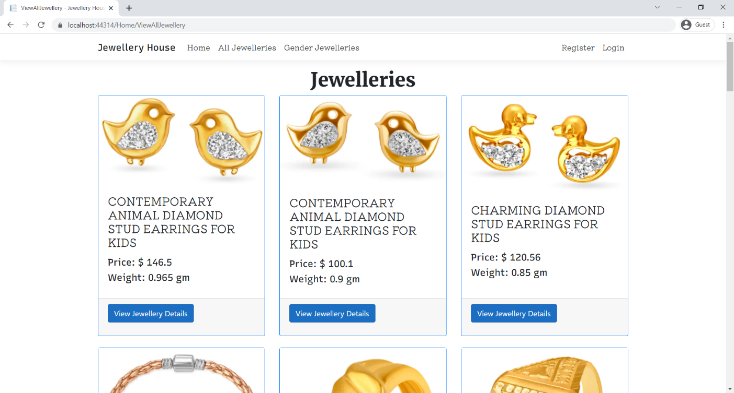

### Jewelleries Details Guest Page

This web page display jewellery details to visitor as well as registered user.

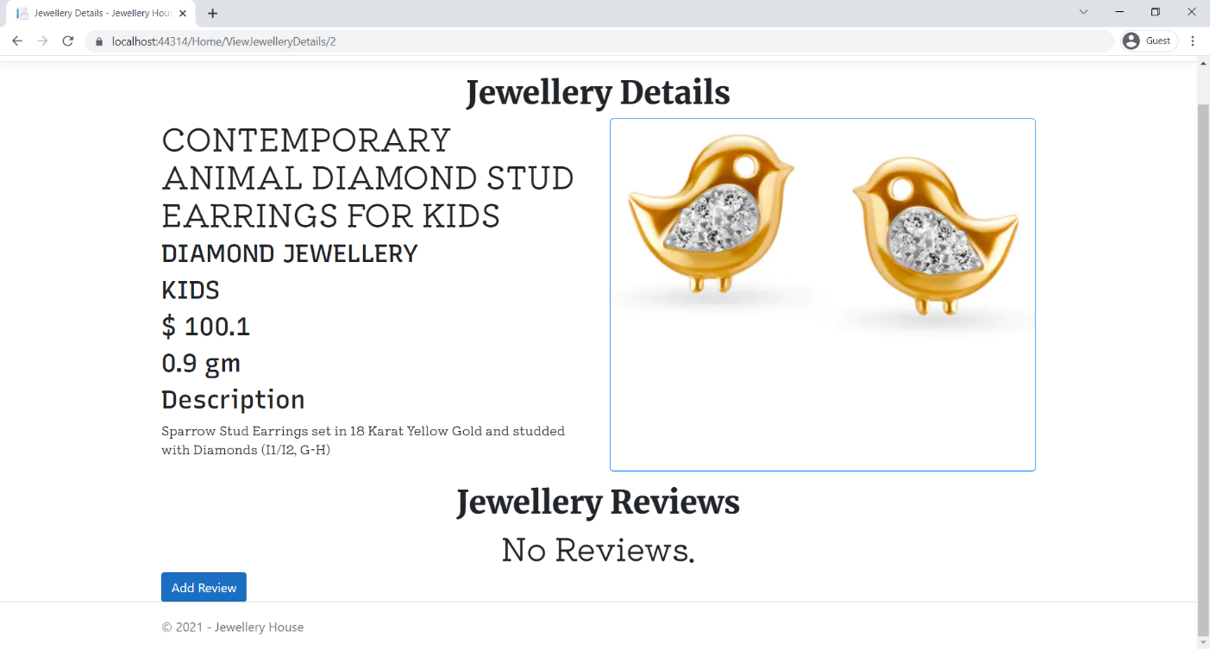

### Add Review User Page

This page is accessible by registered user to share their review.

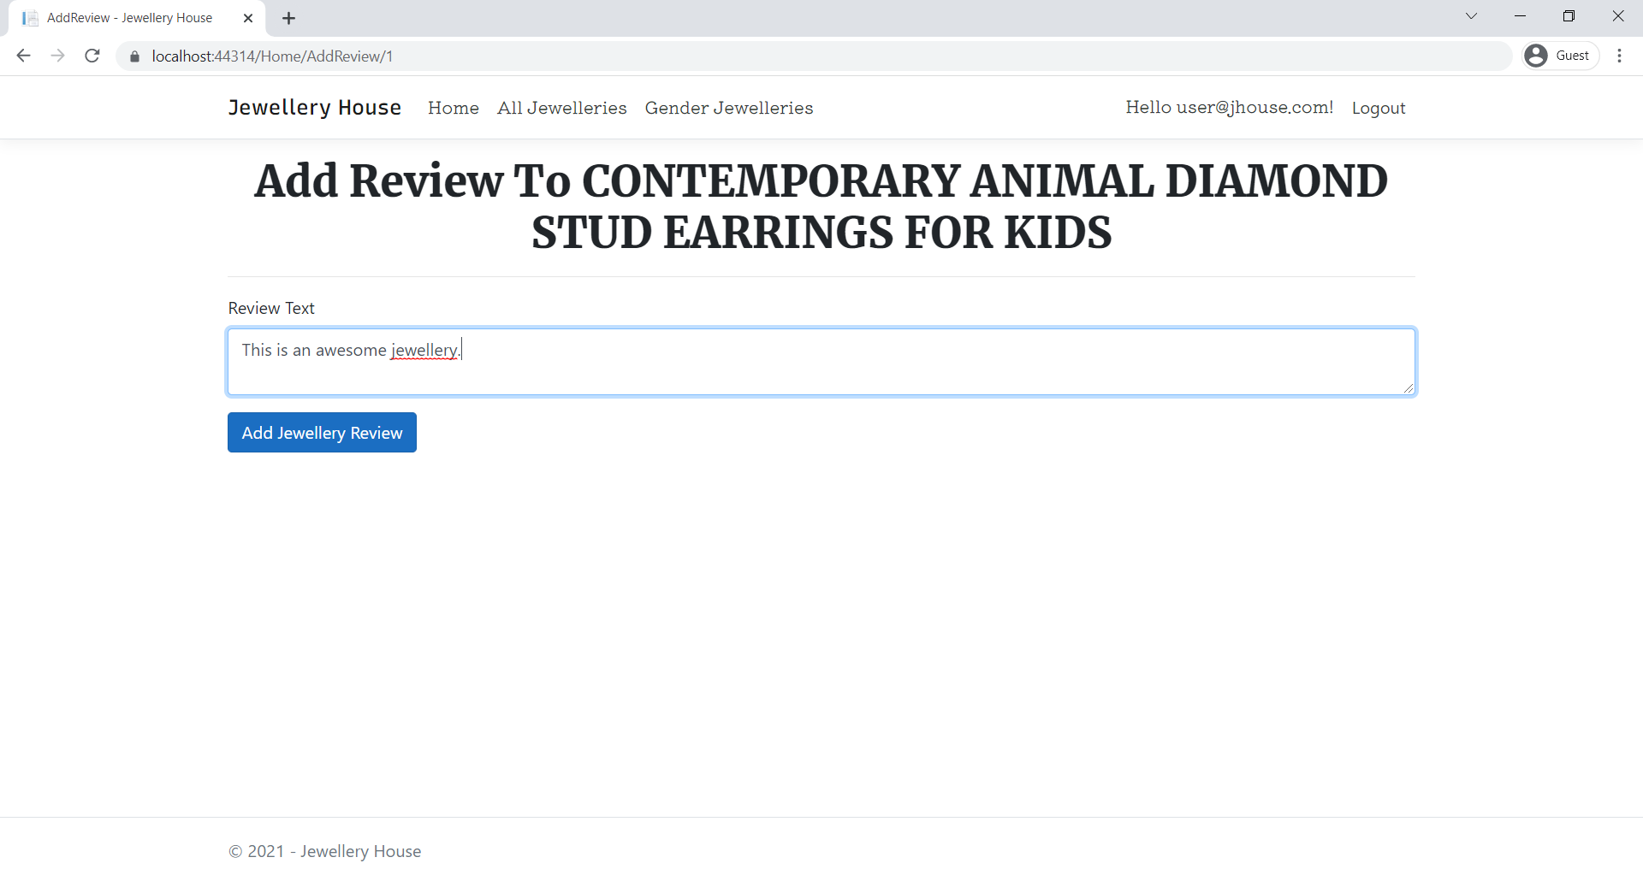

## Project Testing

The testing file for usability testing is attached as [usability test.xlsx](usability%20test.xlsx)

# User Manual

The main purpose of the application Jewellery House provide a central place for visitor for share the information regarding jewellery. In this application there are two types of users- admin and user. Admin is controller of CMS panel of Jewellery House web application content. Registered user is capable to share his/her review to jewellery.

## Summary

### System Configuration

This app will be useful to for distributing mobile information in presentable format.

### User Access Levels

Only registered users can access the features of this application.

* **Admin:** Admin has full access of the app can create new admin.
* **User:** User can login using their own credentials. They have limited access.